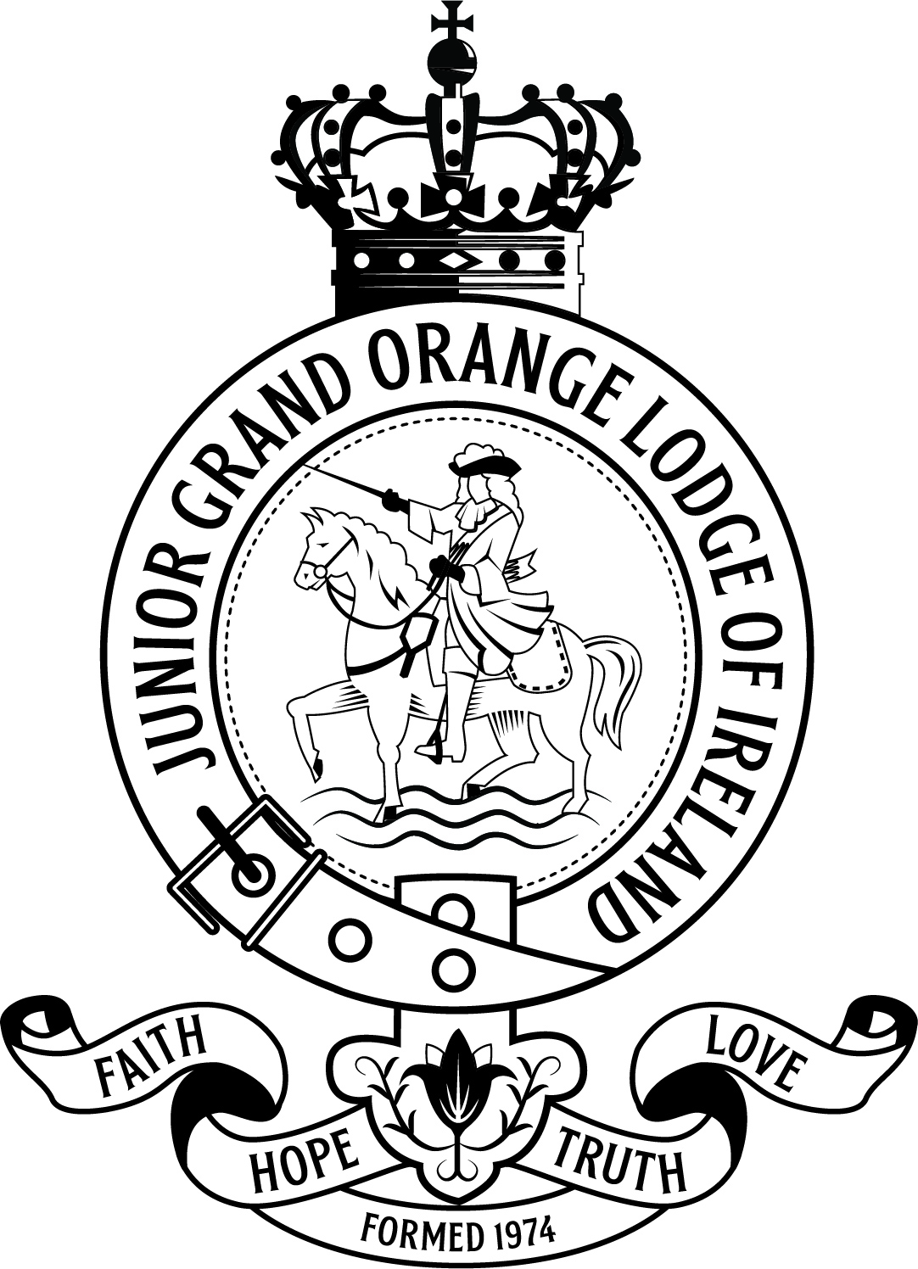
Junior Grand Orange Lodge of Ireland
Community Awards 2025

NOMINATION FORM
JUNIOR GRAND LODGE AWARD 2025

An award for an individual junior member or junior lodge to recognise and outstanding contribution to lodge life, Charity, Community Engagement, or Achievement

Name of Nominee (Individual Nomination):

Parent/Guardian Name:

Nominee Address:

Parent/Guardian Phone No:

Parent/Guardian Email:

Name & Number of Lodge (Lodge Nomination):

Name & Address of Lodge Superintendent:

Superintendent Phone No:

Superintendent Email:

Nominated by:

Address:

Phone No:

Email:

Details of why you are nominating the Individual or Lodge. (Use a separate sheet if necessary)

If you are nominating a Lodge, how many lodge members are involved in the community project/s outlined? (Use a separate sheet if necessary):

Try to estimate the following:

Amount of time spent on these activities by the Individual or Lodge (weekly/monthly or one-off period)?

Numbers assisted in through the project/s the Individual or Lodge is involved with?

Length of time the Individual or Lodge has been involved in main activity outlined (i.e. one year, three years etc.) ?

Please provide an independent contact in relation to the nomination (someone who can be contacted to provide further details and can support your application)

Name

Address:

Lodge Name/No (if applicable):

Phone No:

Email:

Have you included copies of some or all of the following:

Newspaper cuttings
xX
Documentation of any other nature
Confirmation of an independent contact
Anything else which may be helpful to the application.

Please provide as much information and supporting documents as possible. Judges will solely use evidence presented during the decision making process.

If you require any further information relating to the Orange Community Awards or assistance completing this form, please contact us at either of the following.

Tel: 028 9070 1122
Email: ocawards2025@goli.org.uk

Return completed Nomination Form and all supporting documentation to:

Grand Orange Lodge of Ireland
Schomberg House
368 Cregagh Road
Belfast
BT6 9EY

Email: ocawards2025@goli.org.uk

CLOSING DATE FOR NOMINATIONS: Friday 7th February 2025

THANK YOU FOR YOUR NOMINATION!

